Alex Law

CEE244

Final Project

03/23/2018

1. Perform PSHA for the building A & B with hazard level of 2% probability of exceedance in 50 years.

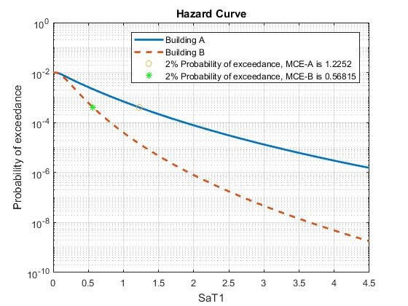

MCE for building A is 1.2252g

MCE for building B is 0.56815g

1. Plot the Expected maximum story drift vs. ground motion intensity for retrofitted and existing buildings

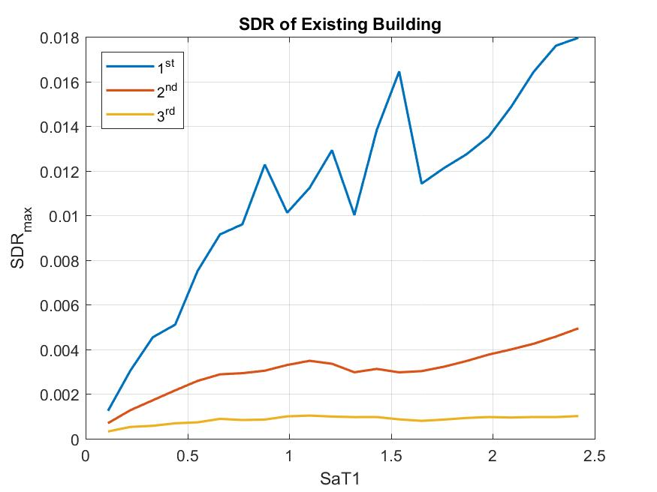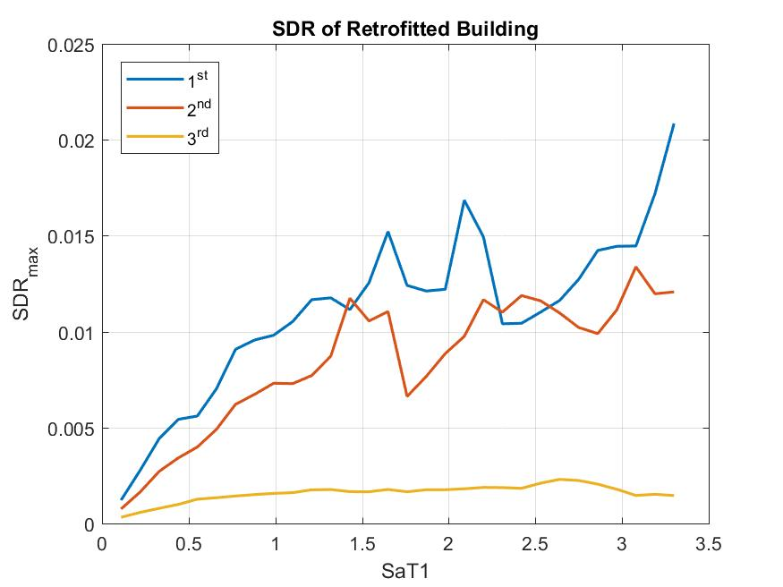

1. Plot the expected peak floor acceleration vs. ground motion intensity for retrofitted and existing building

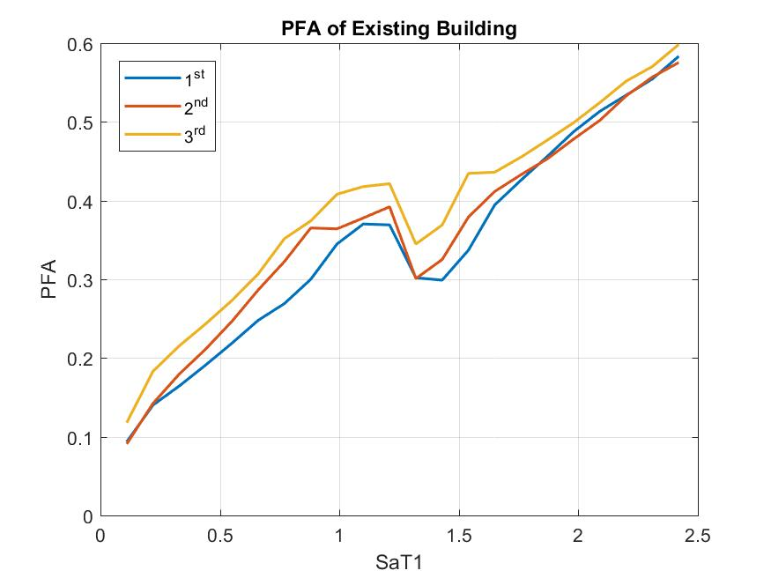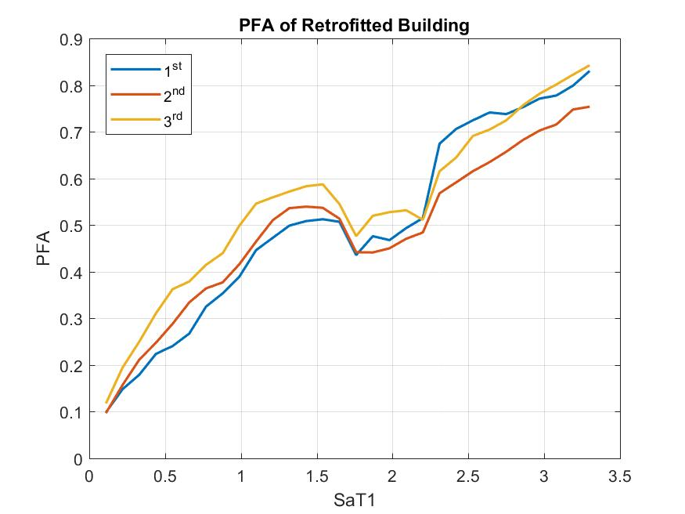

1. Plot the probability of exceedance vs maximum story drifts.

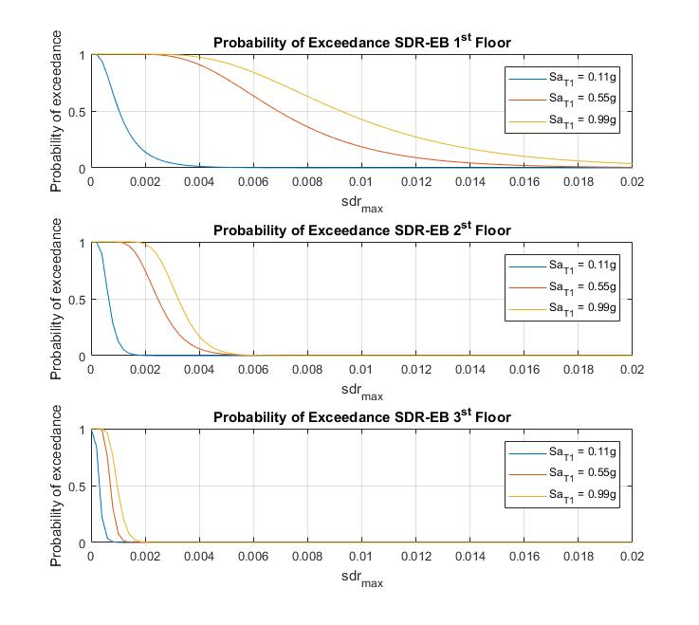

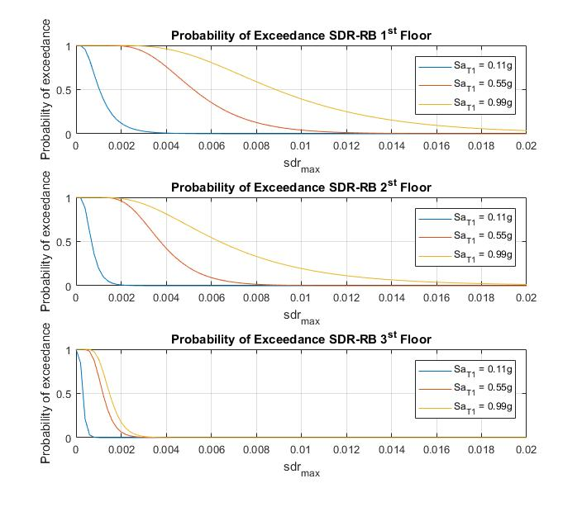

1. Plot the probability of exceedance vs peak floor acceleration

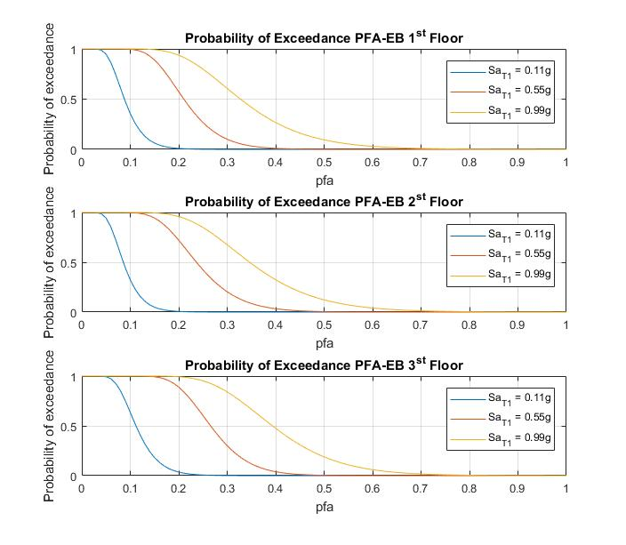

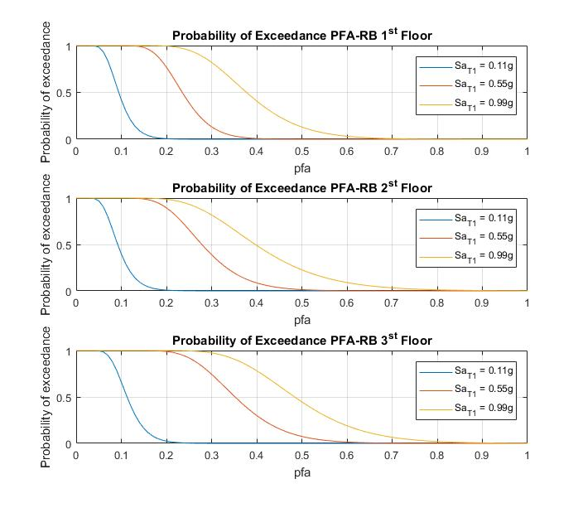

1. Develop the collapse fragility function for the existing and retrofitted building cases
   1. the probability of collapse at the MCE

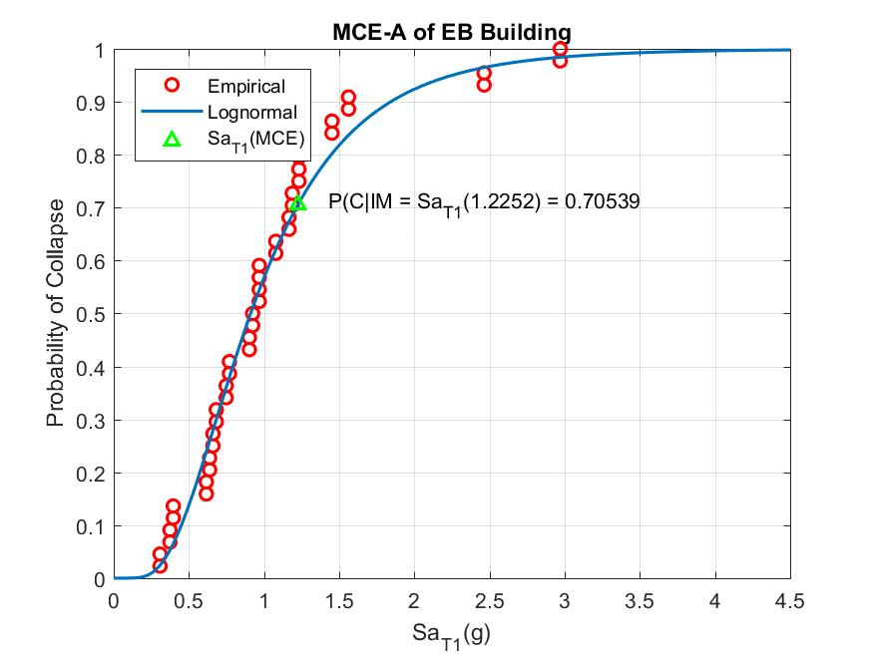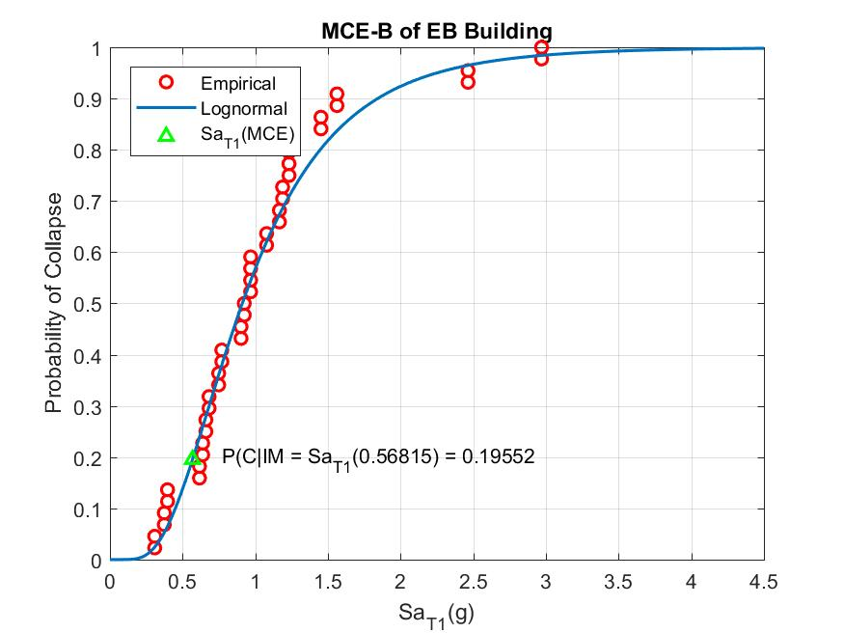

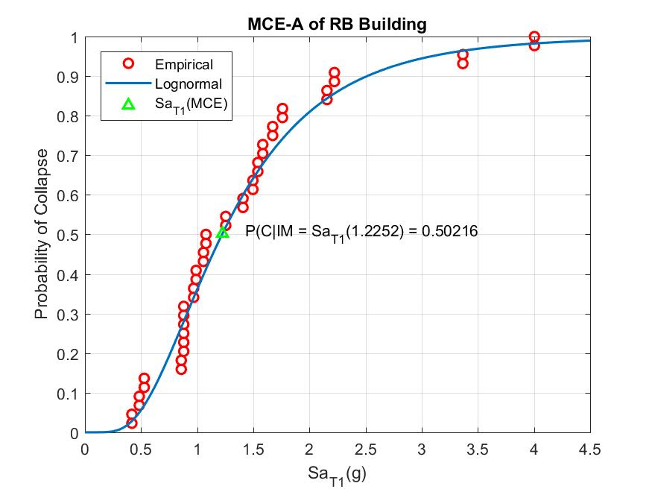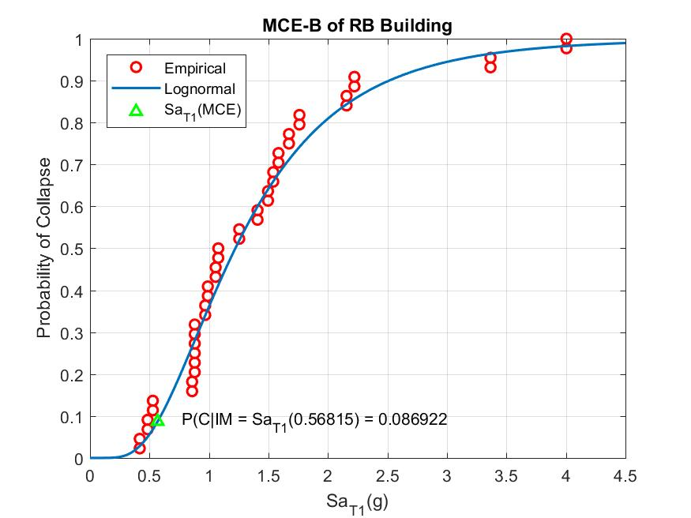

* 1. The median collapse intensity

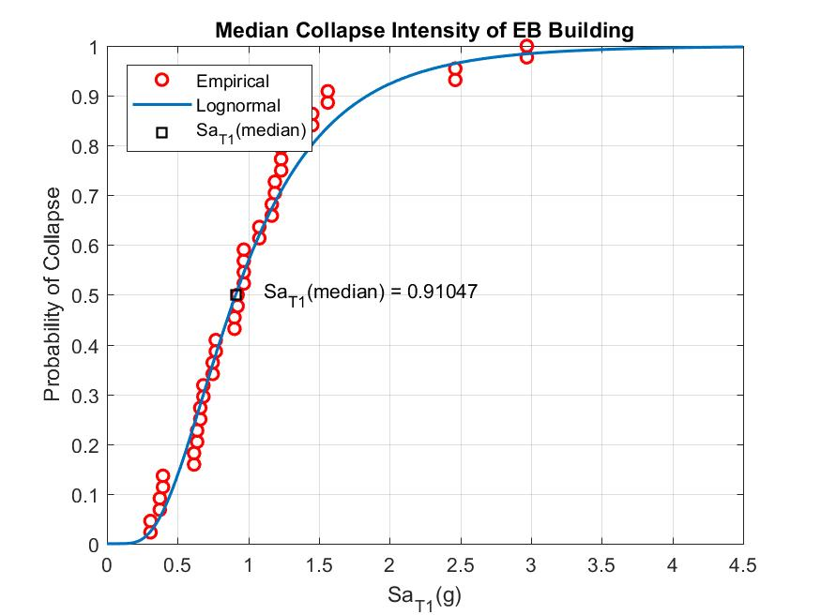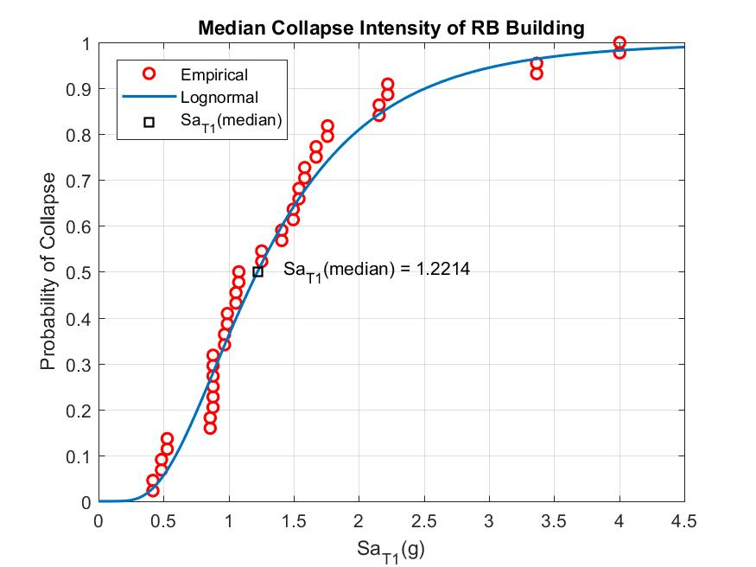

* 1. The collapse margin ratio

The Collapse margin ratio for EB-A is 0.74314

The Collapse margin ratio for EB-B is 1.6025

The Collapse margin ratio for RB-A is 0.99695

The Collapse margin ratio for RB-B is 2.1498

* 1. The mean annual frequency of collapse

Annual frequency of collapse for EB A is 0.0012649

Annual frequency of collapse for EB B is 0.00030247

Annual frequency of collapse for RB A is 0.00076251

Annual frequency of collapse for RB B is 0.00013628

1. Develop and plot the damage fragility functions for the structural and non-structural components and the equipment.

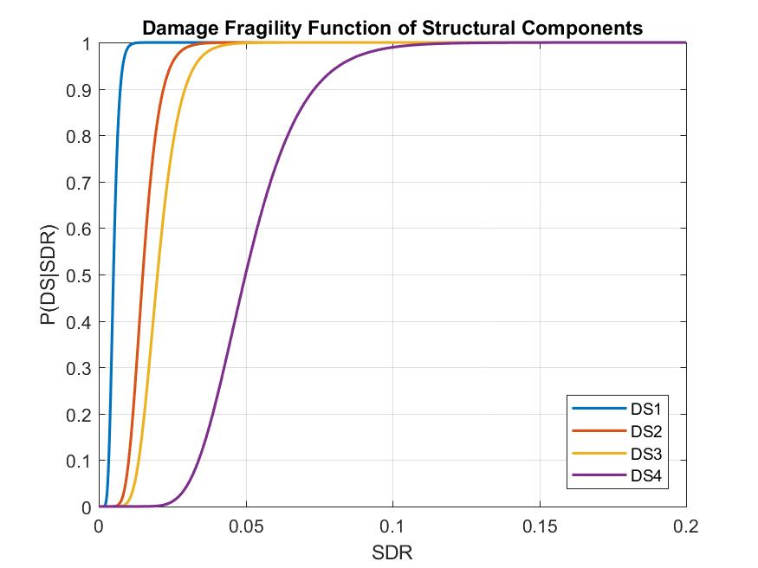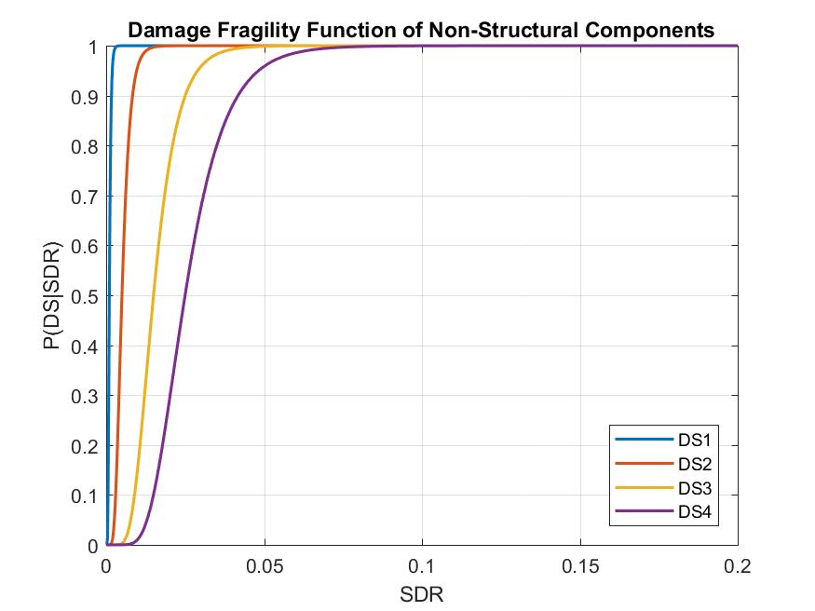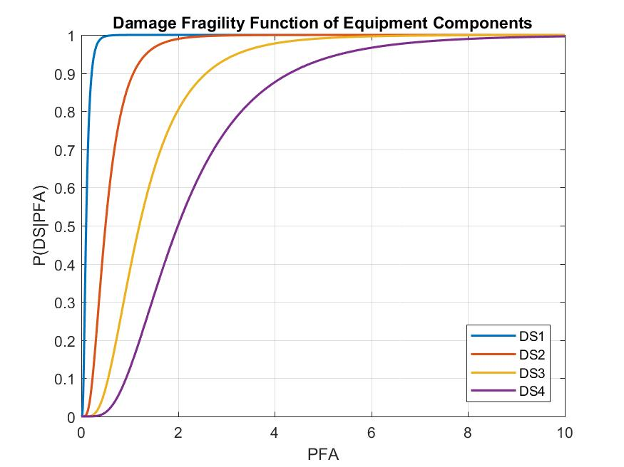

1. The expected non-collapse direct losses due to structural, non-structural and equipment damage as well as total non-collapse loss at each intensity level

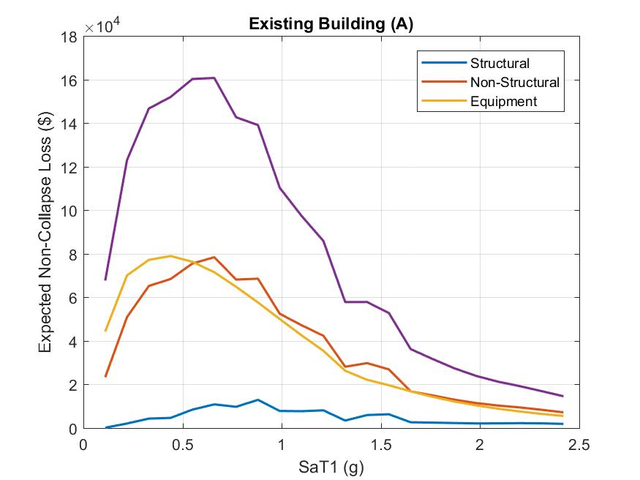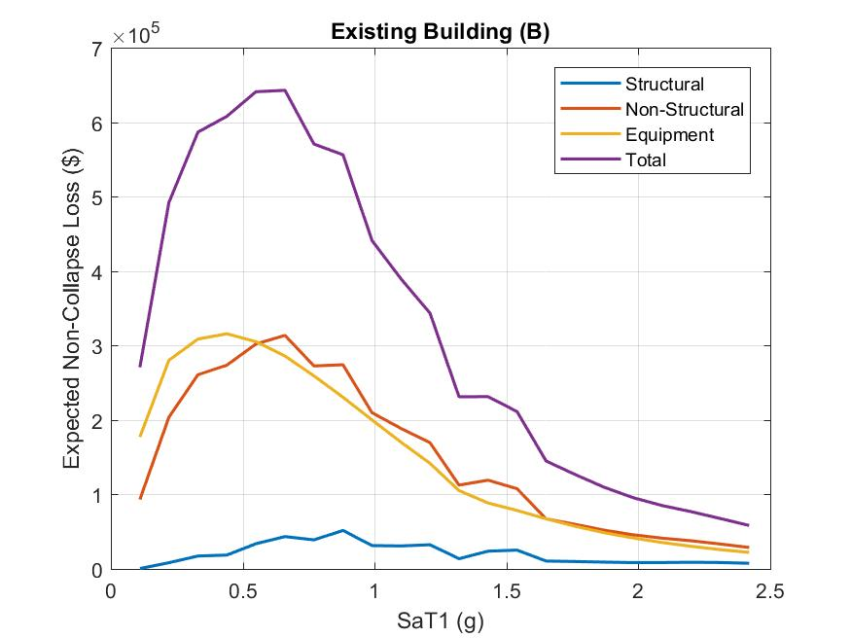

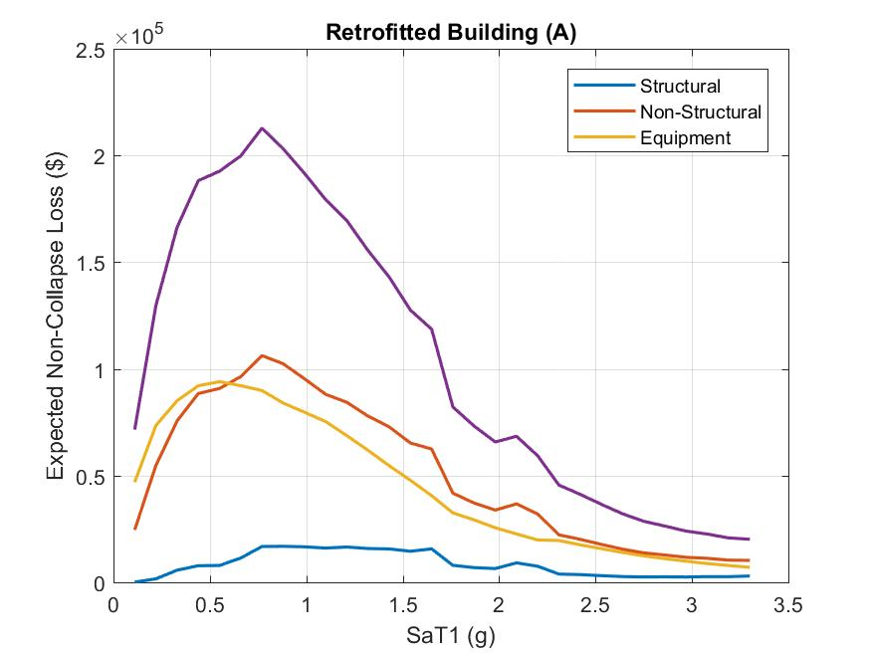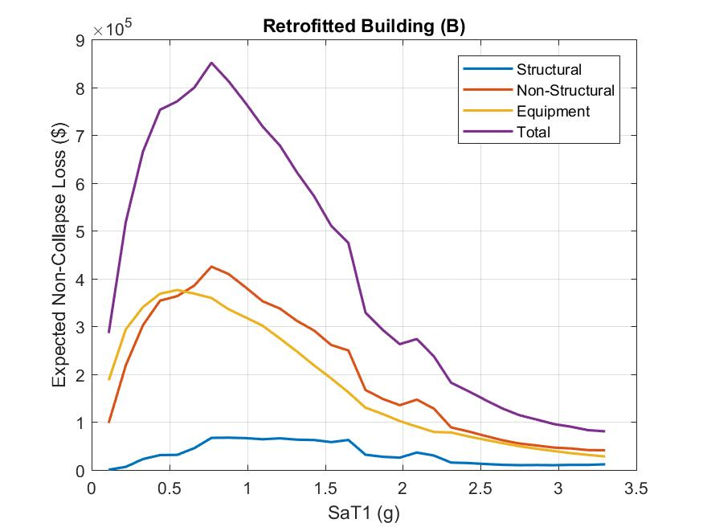

1. Total expected collapse (direct) losses at each intensity level

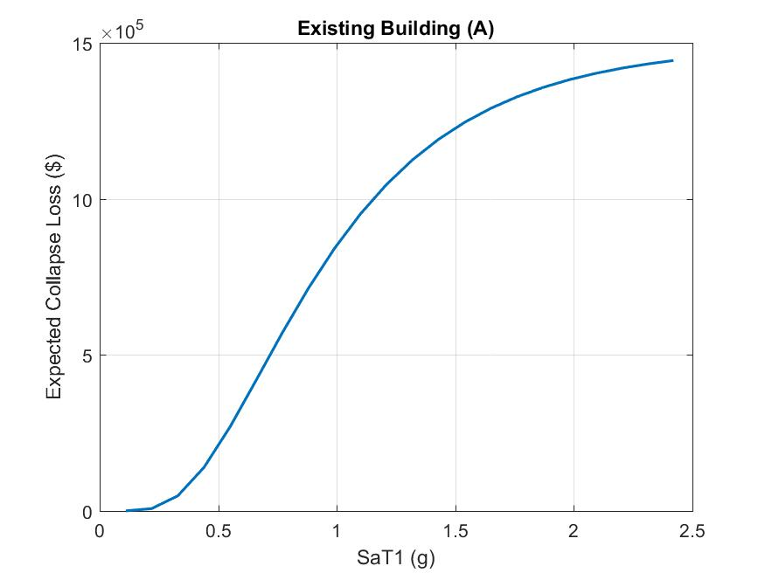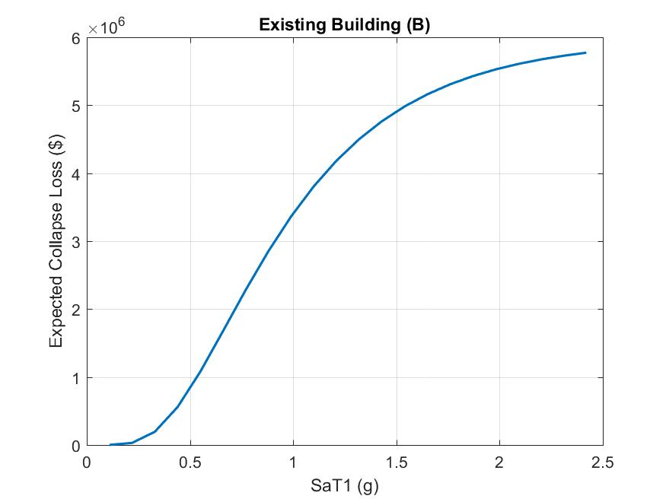

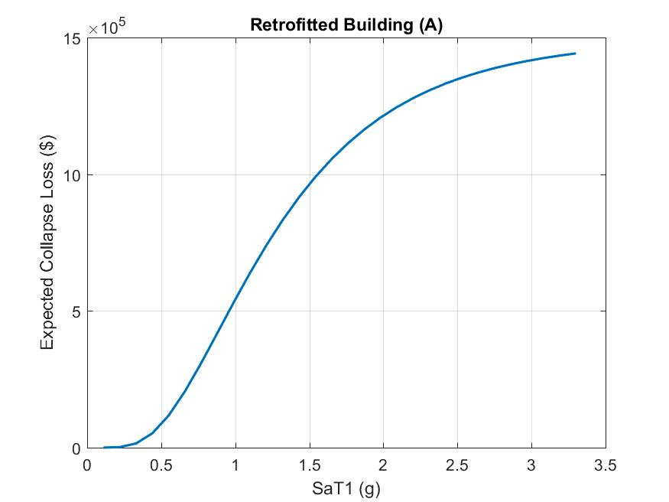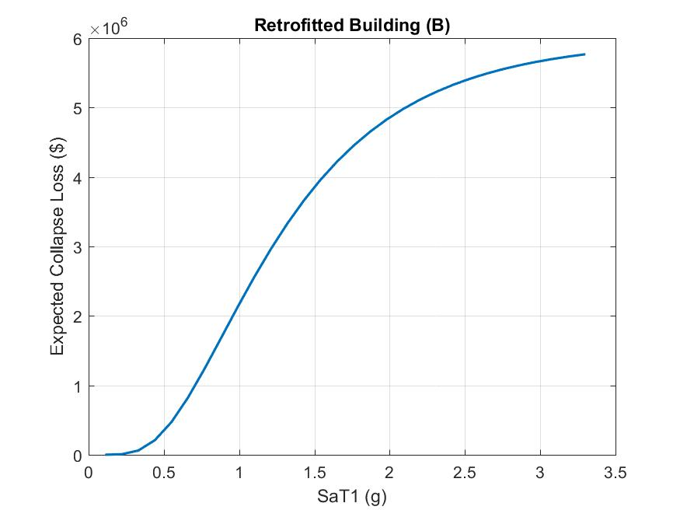

1. expected direct loss at each intensity, Overlay the plots from parts (h), (i) and (j) in the same figure.

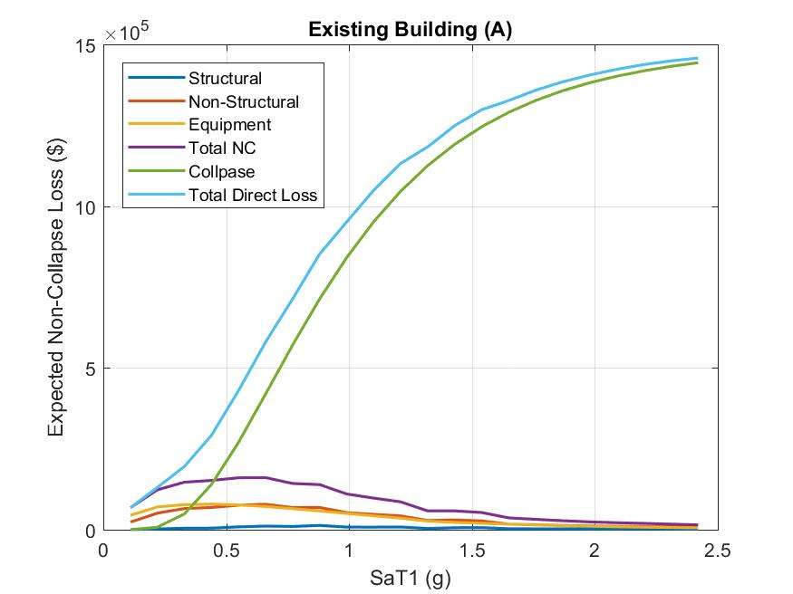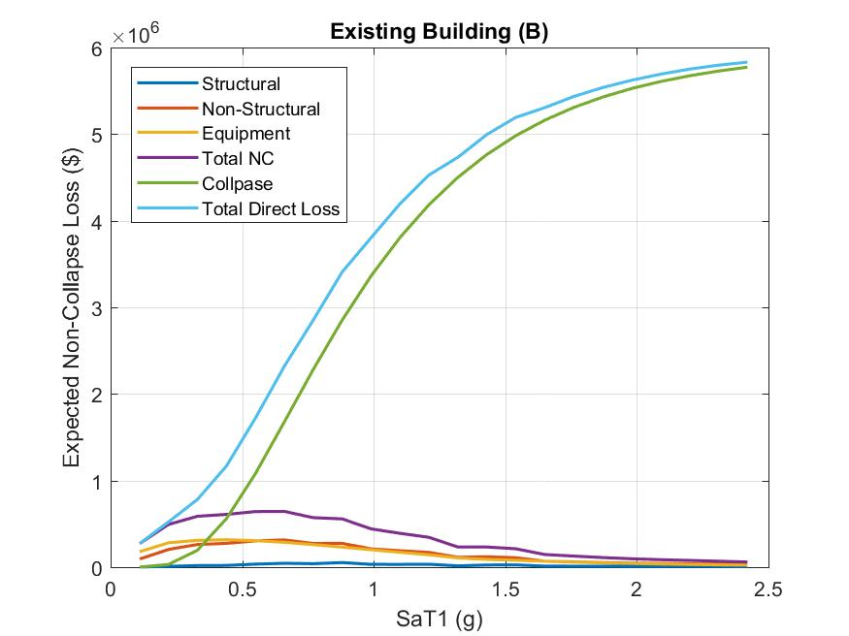

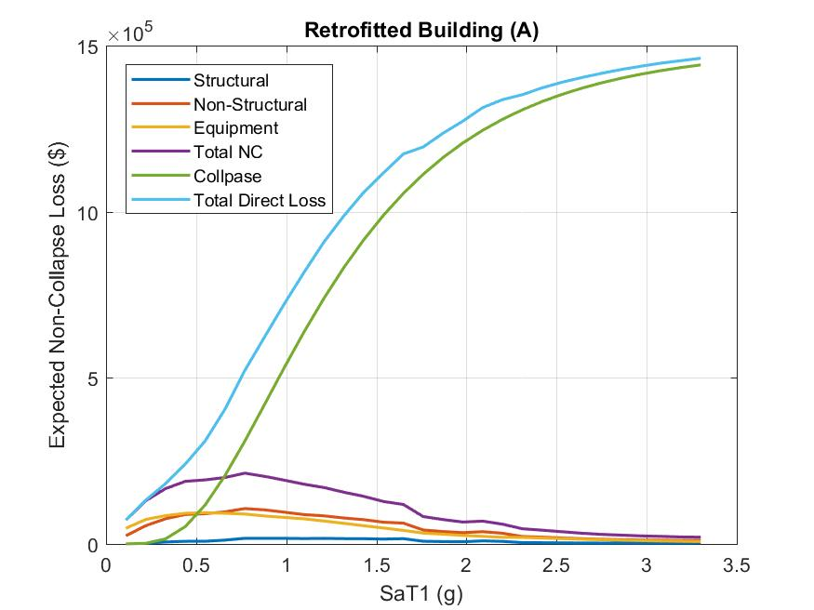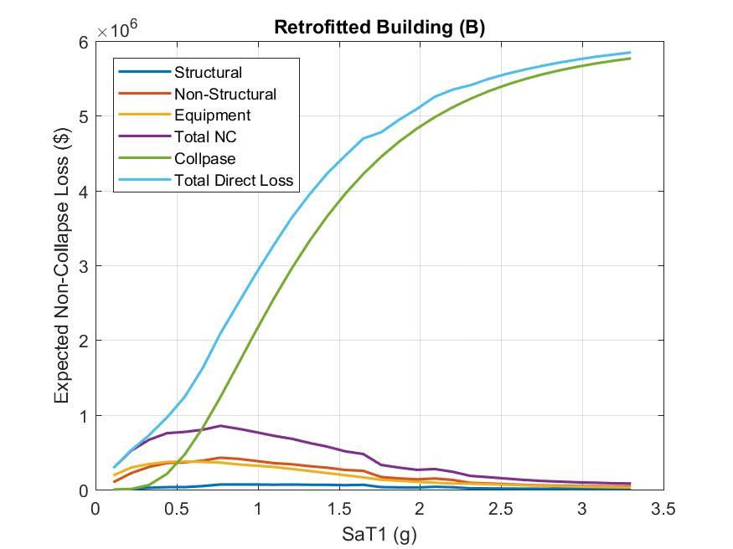

1. The expected annual direct losses and total direct losses over a 10-year period.

Annual direct losses of EB(A) is 3.0047k

Annual direct losses of EB(B) is 6.13k

Annual direct losses of RB(A) is 2.523k

Annual direct losses of RB(B) is 5.6042k

Total direct losses over a 10-year period of EB(A) is 30.0474k

Total direct losses over a 10-year period of EB(B) is 61.2997k

Total direct losses over a 10-year period of RB(A) is 25.2296k

Total direct losses over a 10-year period of RB(B) is 56.0416k

1. Expected loss due to downtime (indirect losses).

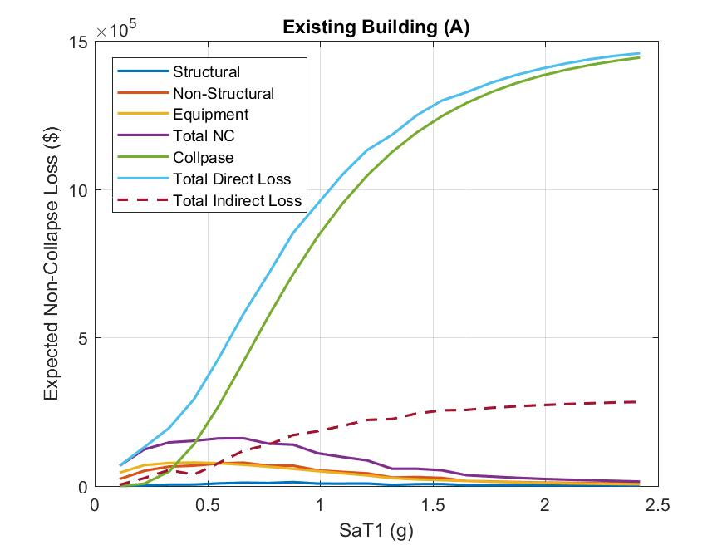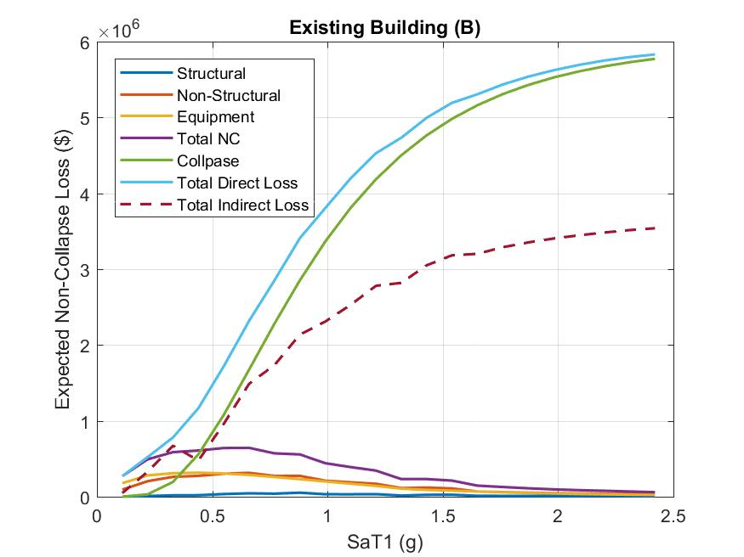

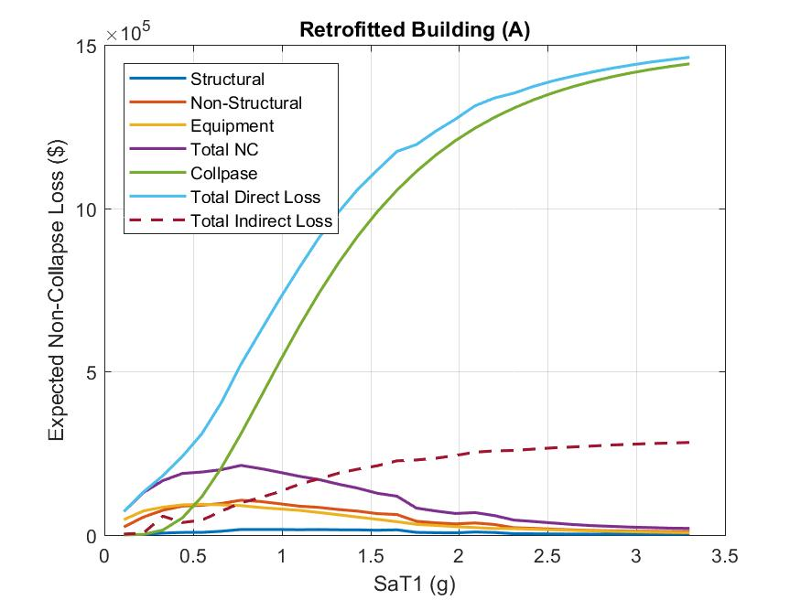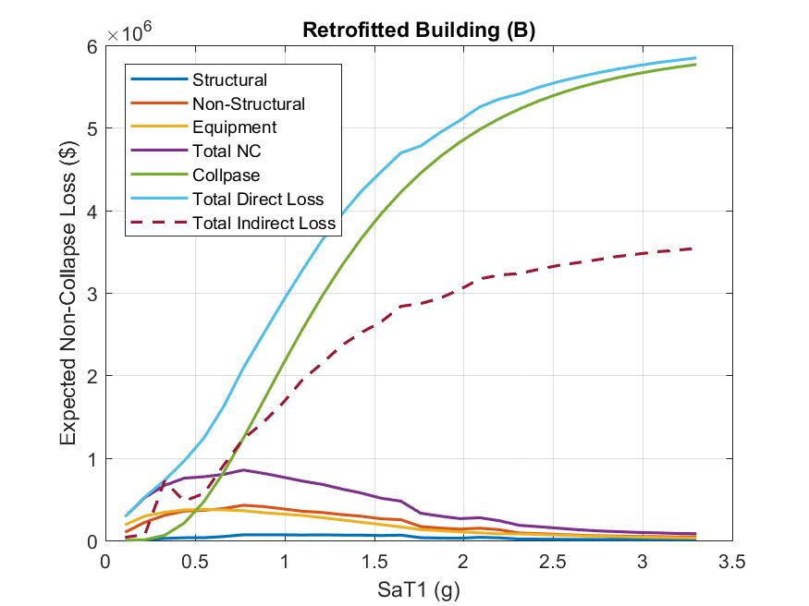

1. The expected loss (direct and indirect) at each intensity measure

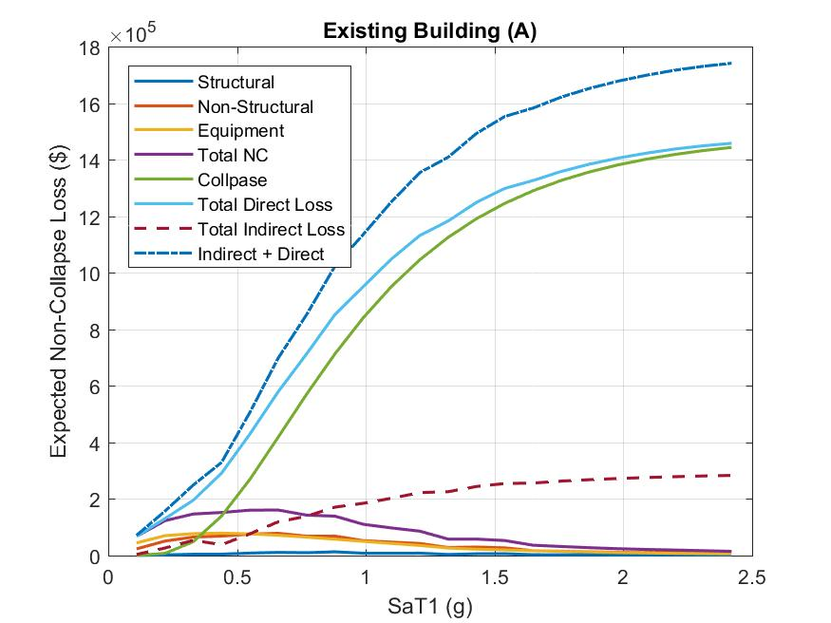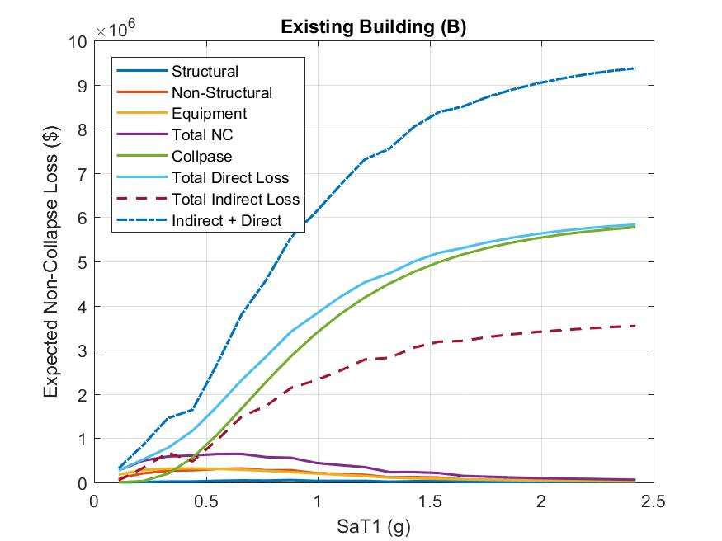

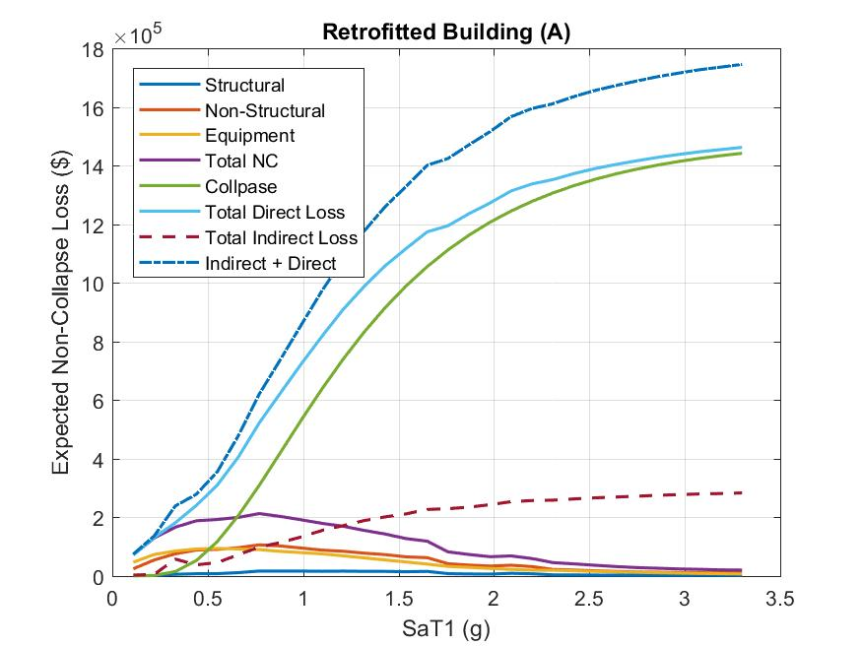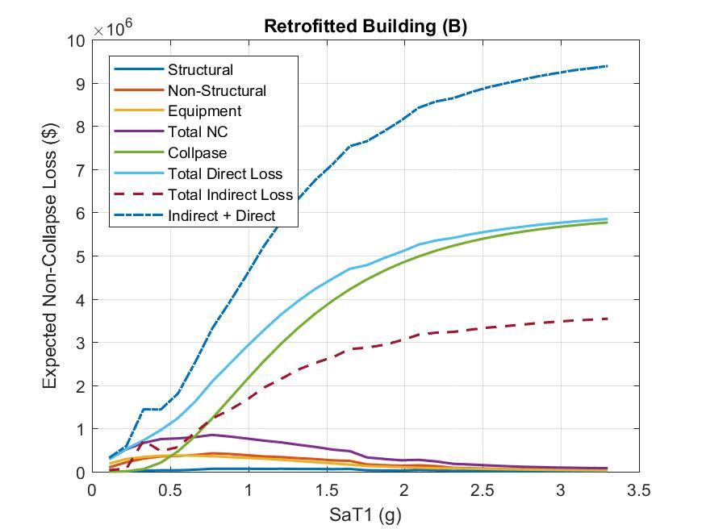

1. Using the hazard curve data compute the expected annual (direct + indirect) losses and total (direct + indirect) losses over a 10-year period.

Annual direct & indirect losses of EB(A) is 3.6259k

Annual direct & indirect losses of EB(B) is 10.5994k

Annual direct & indirect losses of RB(A) is 2.958k

Annual direct & indirect losses of RB(B) is 7.919k

Total direct & indirect losses over a 10-year period of EB(A) is 36.259k

Total direct & indirect losses over a 10-year period of EB(B) is 105.9943k

Total direct & indirect losses over a 10-year period of RB(A) is 29.58k

Total direct & indirect losses over a 10-year period of RB(B) is 79.1905k

1. Extra Credit: Perform a disaggregation on magnitude (M) and distance (R) at SaMCE and generate a 3D plot

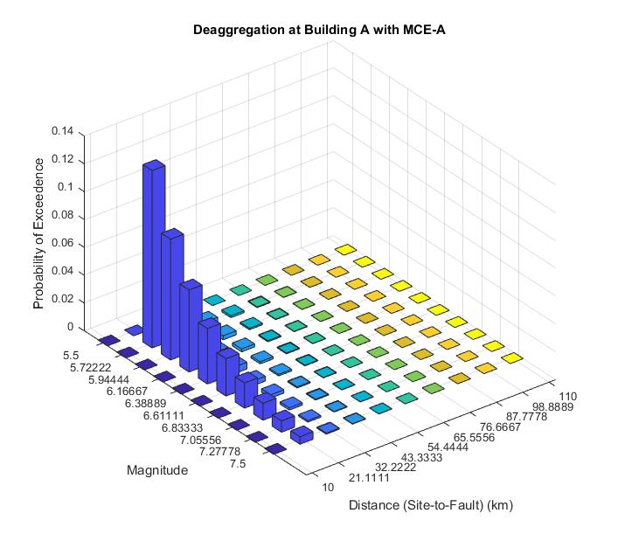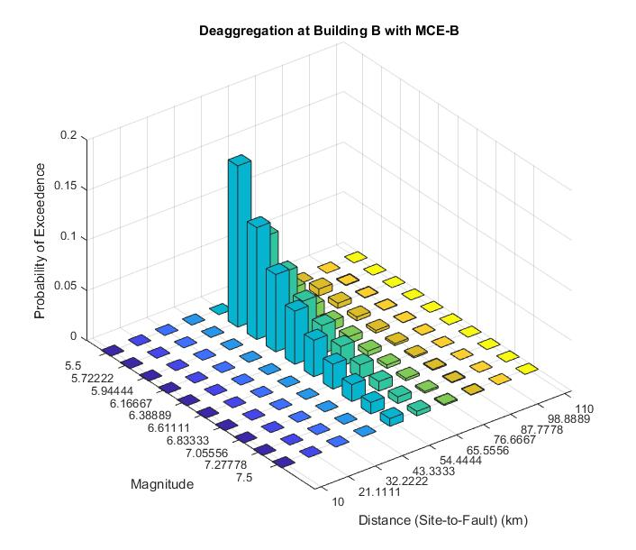

1. Decisions
2. Only direct losses are considered (from part k)

the total reduction ratio in 10 years period of

building A is | (25.2296-30.047) |/30.047 = 0.16;

building B is | (56.0416-61.997) |/61.2997 = 0.0858.

1. Both direct and indirect losses are considered

the total reduction ratio in 10 years period of

building A is | (29.58-36.259) |/36.259 = 0.184;

building B is | (79.1905-105.9943) |/105.9943 = 0.253

I would like to retrofit the building B, because the total loss (direct and indirect) reduction is higher than building A in long terms.

I separate the project into **part_a.m** & **part_b_to_o.m** files.

**part_a.m** is probabilistic seismic hazard analysis (PSHA) file. It takes around 25 minutes to run out a plot of hazard curve. Also, in the following parts of the project need the data from part a. In this case, I have save the **PSHA.mat** which includes all the require data for the rest of parts.

**Part_b_to_o.m** is the rest parts of the project. Since I have saved the require data from part a and I have the load function in it, you can directly run this file to obtain my answers of part b through part o. It would take around a minute.

All the figures will be saved in the **figure folder**. (I have attached my plots in figure folder already. If you run my code, the new figure would replace the old one. However, they should be the same.)

Alex Law (304613872)

03/23/2018